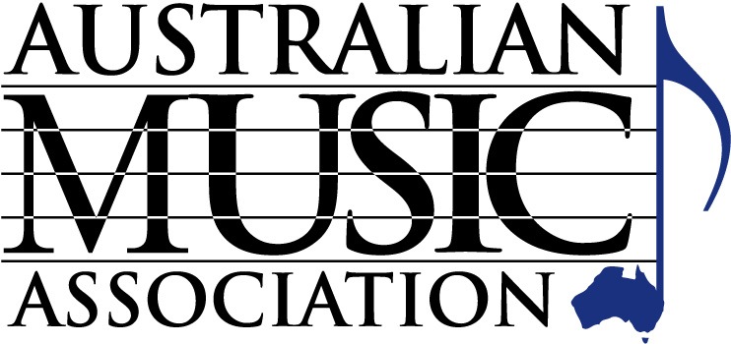

AUSTRALIAN MUSIC ASSOCIATION
PO Box 1035
Huntingdale, Victoria, 3166 Australia
Tel (03) 9254 1019
Fax (03) 8610 1936
Email info@australianmusic.asn.au

APPLICATION FOR MEMBERSHIP- RETAIL
Valid from 1 July 2018 to 30 June 2019

Conditions of Application - Retail membership of the Association is considered subject to:
- The applicant being deemed a bona fide retailer of musical product by the Executive Committee (bona fide retailer refers to the primary function of the business being the retailing of musical products)
- The applicant being nominated by two Association members as being bona fide as defined above
- Upon acceptance a full year’s membership is charged, which is then applied pro-rata for the second year
- Resignation of membership is only accepted in writing accompanied with any outstanding dues
- No refunds are given for membership fees
- The appropriate membership fee accompanying this application - fees currently applying are as follows:

Number of employees - Please tick the relevant box and your selected payment option

1-3  $295* Full Payment or $24.60 per month ($295.20 total)
4-9  $595* Full Payment or $49.60 per month ($595.20 total)
10+  $995* Full Payment or $83.00 per month ($996.00 total)
* All fees include GST

Registered Business Name:

Proprietor(s):

ABN No:

Trading Name:

Address :

Post code:

Telephone: Fax:

Email/Website Address:

I/We hereby make application for membership of the Australian Music Association, and if approved, I agree to pay the appropriate fee and abide by the general rules, regulations and the constitution of the Association, and recommendations of the Executive Committee.

Signed by the Applicant: Date:

Proposed by: Member Company:

Seconded by: Member Company:

AUSTRALIAN MUSIC ASSOCIATION
PO Box 1035
Huntingdale, Victoria 3166

Tel (03) 9254 1019 Fax (03) 8610 1936
Email info@australianmusic.asn.au

MEMBERSHIP PAYMENT FORM

Company Name:

As per our membership application form, we wish to pay our membership subscription as follows:

$......... discount upfront payment * or $......... per month

Payment Method (please tick the appropriate payment method)

Full payment upfront by EFT

Monthly Instalments by EFT (these must be set up as a regular payment with your bank)

EFT Details: Account Name: Australian Music Association
Bank: ANZ BSB: 013 427, Account no: 4404 82437

Cheque (cheques payable to ‘Australian Music Association’)

Full payment upfront by Credit Card

Monthly Instalments by Credit Card (2.4% surcharge applies to instalments)

Visa Mastercard

Card Number:

Amount: Expires: CVV

Name as it appears on card:

Signature:

ABN: 58 026 169 284

Or pay online at http://australianmusic.asn.au/payment-page.asp

